**Ayesha Zubair**

**52916**

**Lab 6**

**Task 1:** Write a C program that print your name and sap id and Show the output.

**Code:**

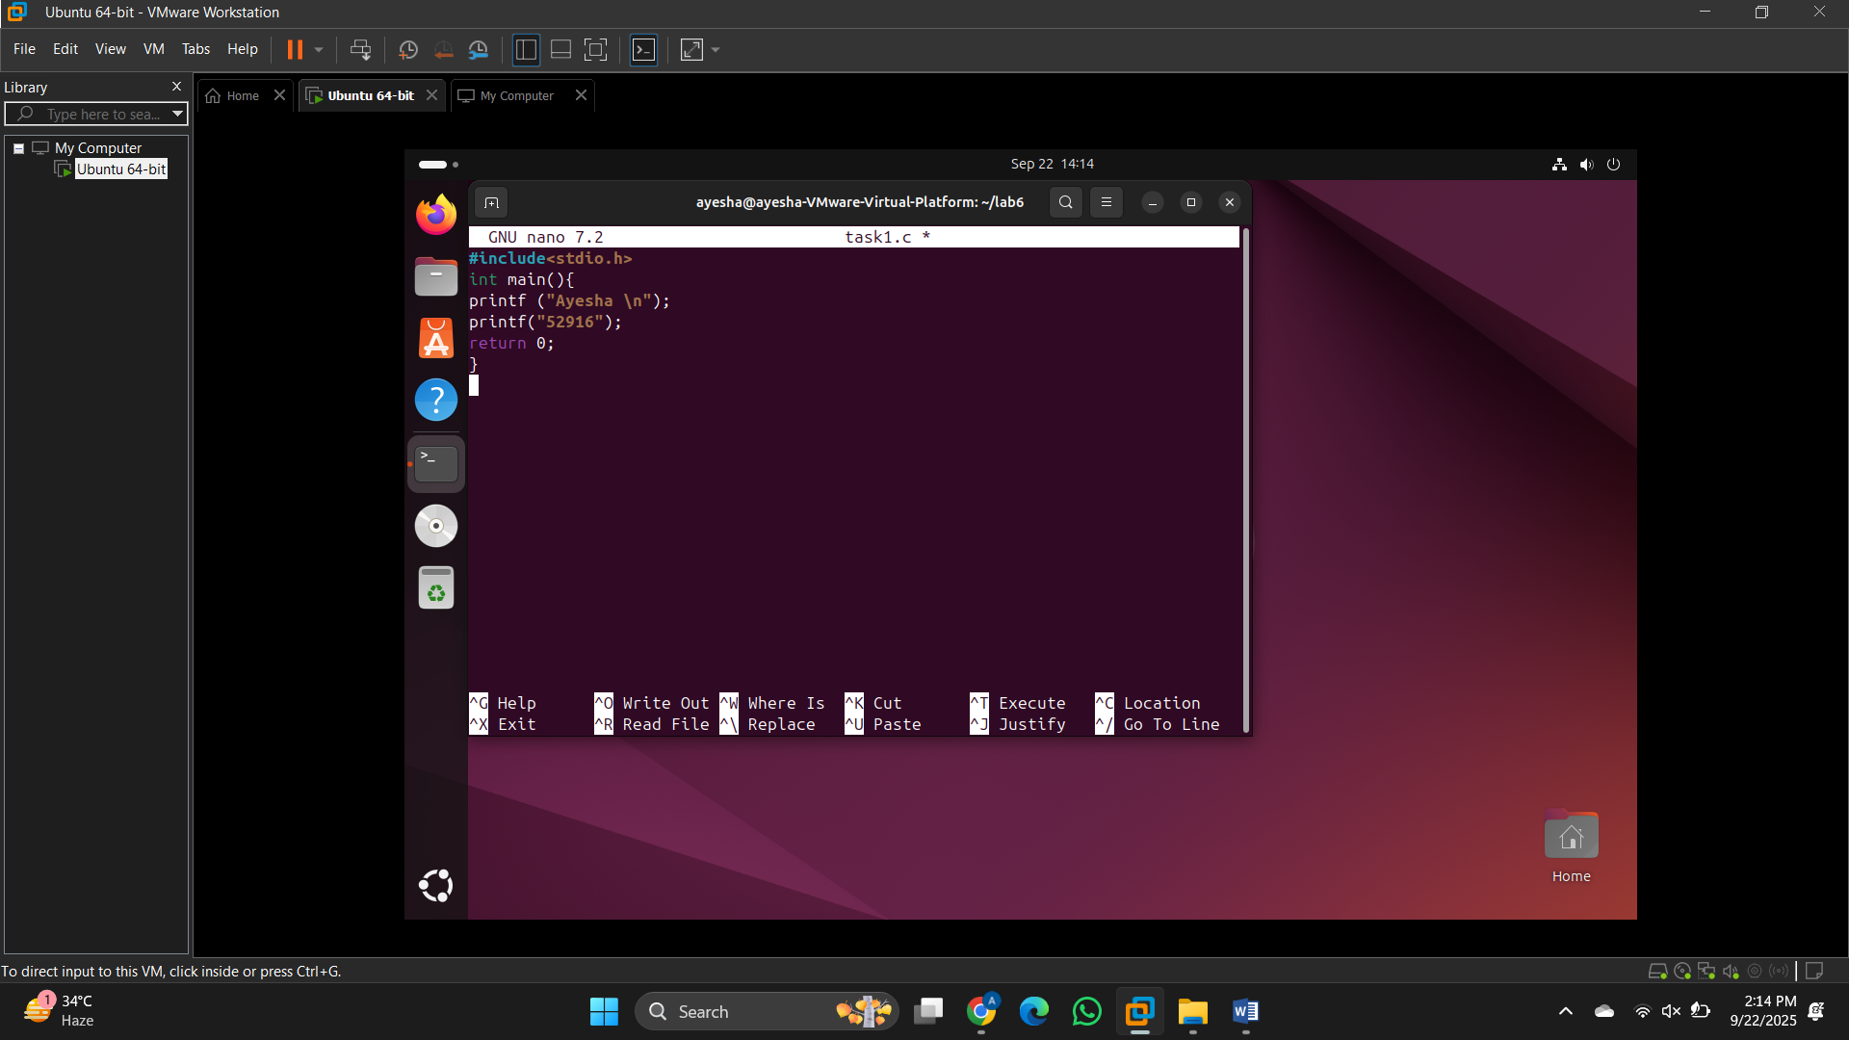

**Output:**

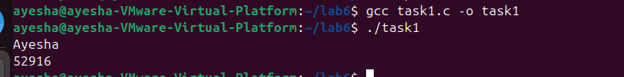

**Task 2:** Write a C program that asks the user to enter a number and determine whether the number entered is even or odd. Show the output.

**Code:**

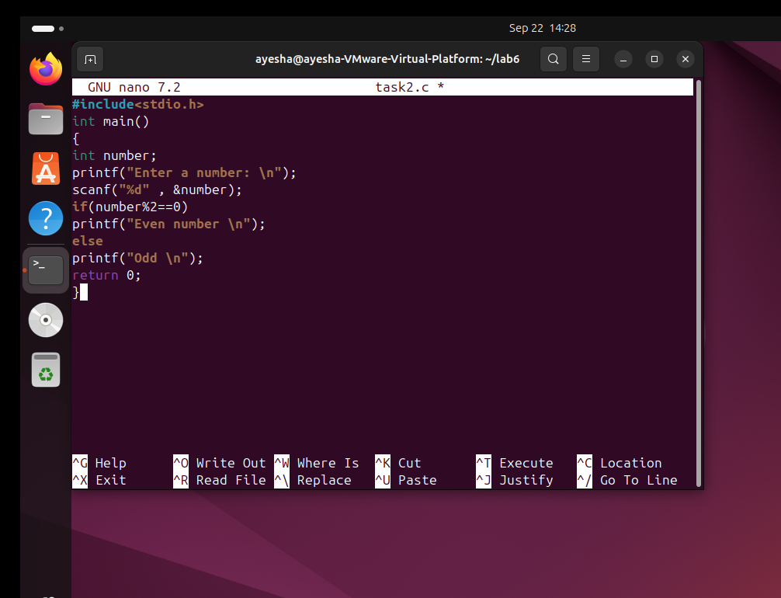

**Output:**

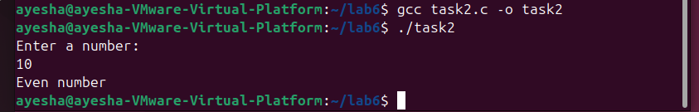

**Task 3:** Write a C program to calculate the factorial of a number using a while loop take a number from user.

**Code:**

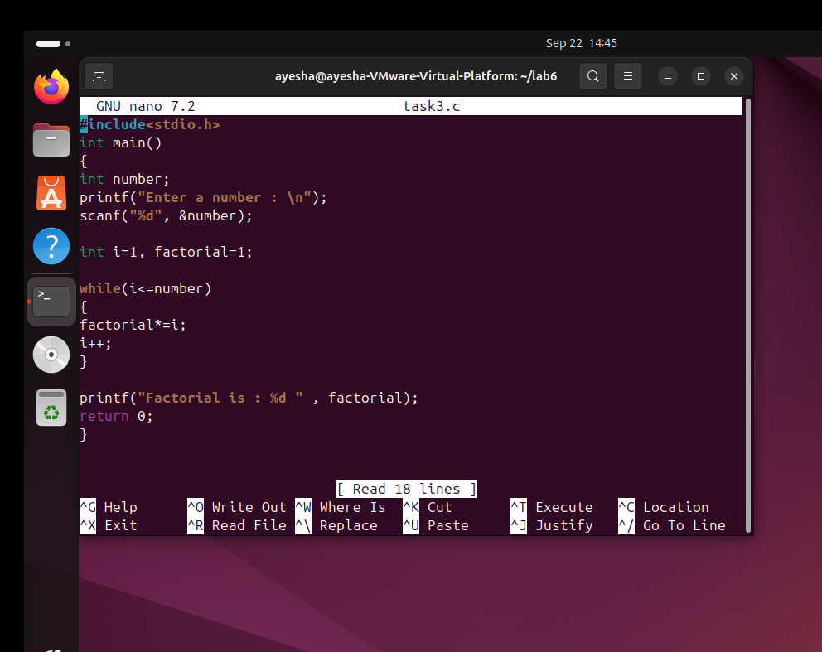

**Output:**

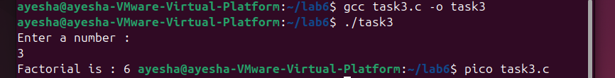

**Task 4:** Write a C program that uses an infinite for loop to print a name continuously.

**Code:**

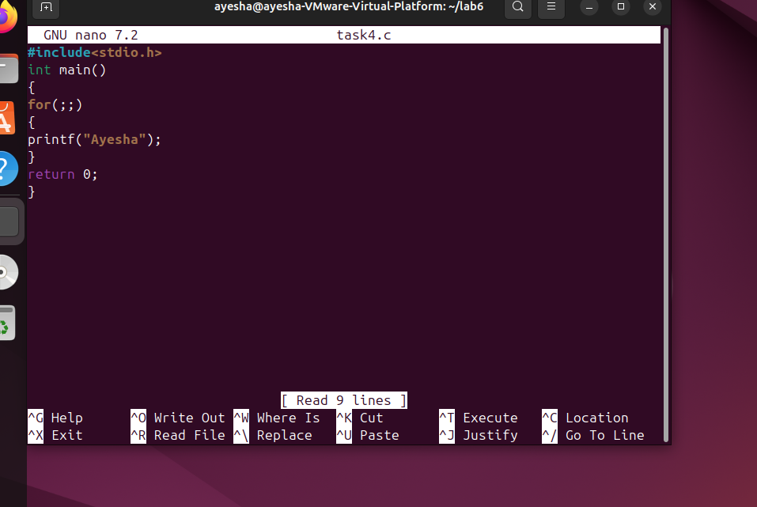

**Output:**

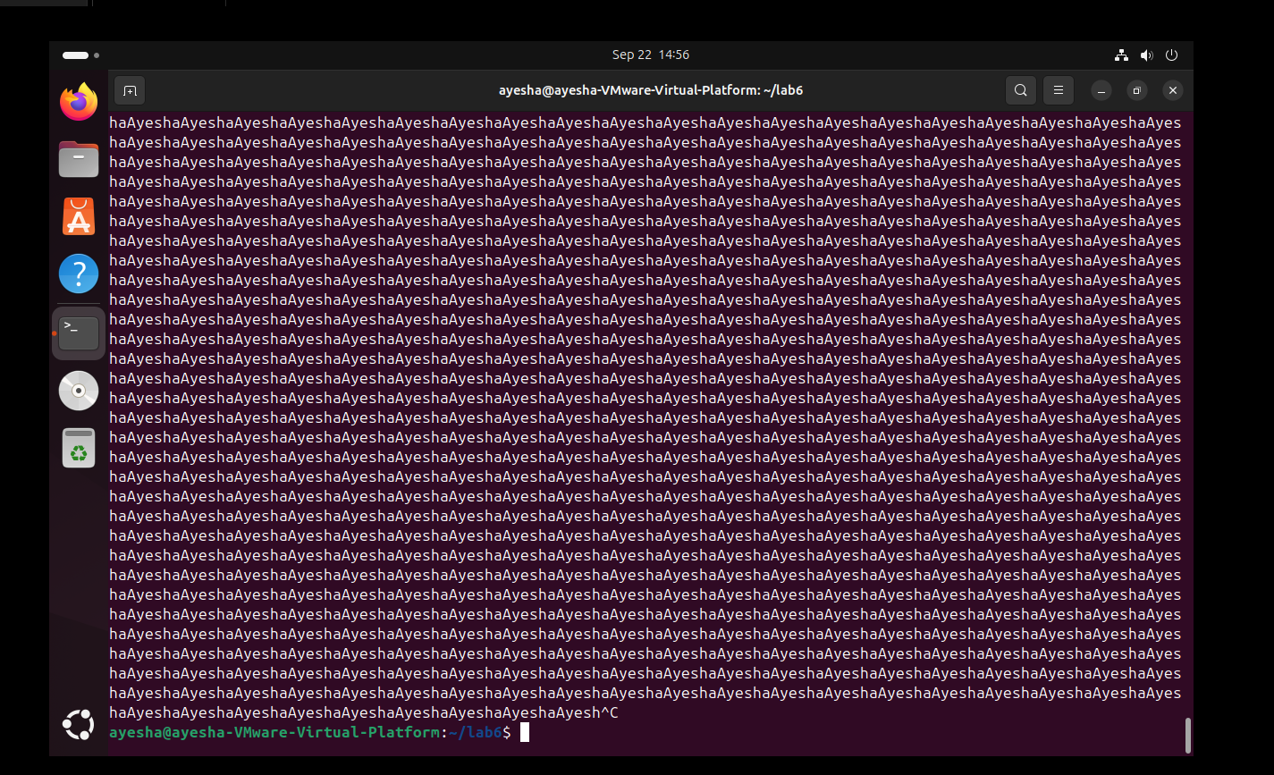

**Task 5:** Write a program to print average of three numbers in c program.

**Code:**

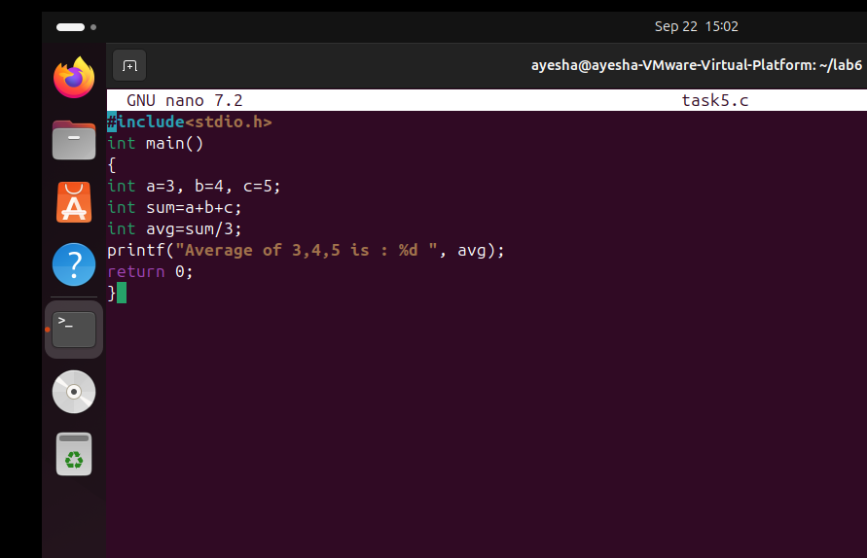

**Output:**

